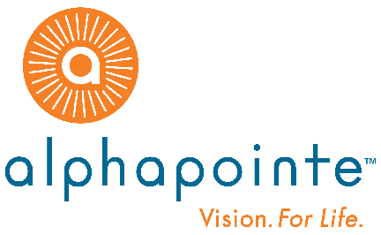

**NEWS RELEASE**

**Contact:**

Gina Gowin

Vice President, Alphapointe

**For Immediate Release**  816.237.2025 / 816.809.6770

ggowin@alphapointe.org

**Alphapointe Earns 2017 Employment Growth Award**

**From National Industries for the Blind**

*Award Honors Success in Sustaining and Increasing Employment*

*For People Who Are Blind*

**January 24, 2018, Kansas City, MO ~** Alphapointe was honored by National Industries for the Blind (NIB), the nation’s largest employment resource for people who are blind, with the 2017 Employment Growth Award. The award recognizes Alphapointe’s outstanding efforts to increase employment retention, growth and upward mobility for people who are blind.

“We are proud to provide aspirational career opportunities for people who are blind in Missouri, New York and other areas across the country,” said Reinhard Mabry, President & CEO of Alphapointe. “This is the third year in a row that Alphapointe has won this national award, and we are very proud to receive this honor. Our associates are talented, dedicated professionals, and we are very pleased that they are recognized as an example of the capabilities of people who are blind in the workforce.”

Employment Growth Award recipients receive a cash payment from a fund created to recognize and encourage NIB associated nonprofit agencies who have successful results in retaining or increasing employment for people who are blind by providing products and services through the AbilityOne® Program, and for achieving success in the areas of placement and upward mobility.

“Alphapointe is doing an outstanding job of creating U.S.-based career opportunities for people who are blind,” said Kevin Lynch, president and CEO of NIB. “This is a great example of the unlimited capabilities of people who are blind working in Missouri and New York, and across the country.”

###

**About Alphapointe**

Alphapointe, headquartered in Kansas City, MO has been empowering people with vision loss to achieve their goals and aspirations since its founding in 1911. Alphapointe, the third largest employer of people who are blind in the U.S., with manufacturing facilities in both the State of Missouri and the State of New York, has nearly 400 employees, of which 225 are blind or visually impaired. Alphapointe is one of the largest resources for people with vision loss, offering products and services nationwide. Alphapointe’s business lines include plastics, micro-molding, office products manufacturing and sales, textiles manufacturing and sales, janitorial products, contact center services, retail stores and comprehensive rehabilitation and education programs for people who are blind or are losing their vision. For more info about Alphapointe, visit [www.alphapointe.org](http://www.alphapointe.org).

**About National Industries for the Blind**

For more than 75 years, National Industries for the Blind (NIB) has focused on enhancing the opportunities for economic and personal independence of people who are blind, primarily through creating, sustaining and improving employment. NIB and its nationwide network of 94 associated nonprofit agencies serve as the largest employer for people who are blind by the sale of SKILCRAFT® and other products and services through the AbilityOne® Program, established by the Javits-Wagner-O'Day Act. For more information about NIB, visit [www.nib.org](http://www.nib.org).